**GATEBOX**

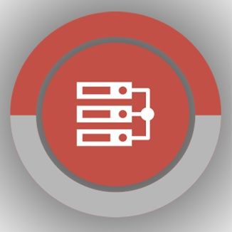

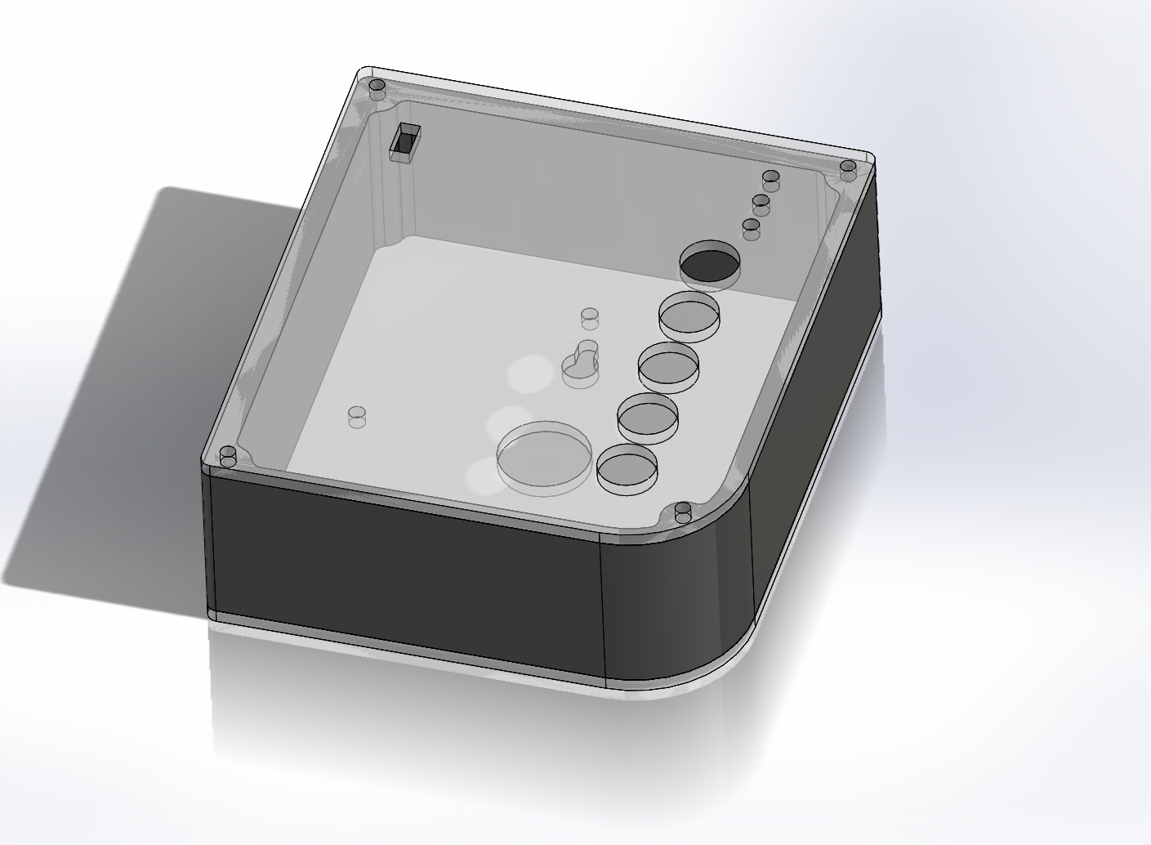

**Shafeeq Rabbani**

**Paul Calinescu**

**Edgar Malchic**

**Esther Baruti**

**Why are we doing this?**

We would like to make a positive impact in millions of households in the coming years by making the lives of homeowners more convenient and providing them with more control over their homes.

**How are we going to do this?**

Today, we have smartphones that can operate Bluetooth peripherals in a house and cars which can be paired with smartphones. Such cars are commonly referred to as connected cars. We would like to combine these two so that your connected car interacts with your house.

**What are we making?**

The GateBox.

There are two components to this system. First, is the panel which sits into the garage of your home. The second is the Windows Phone app which interacts with the panel in order to do some pretty interesting things in the garage.

Now, I know what you are thinking. How does the car enter the picture?

Currently, in the connected car market, solutions such as MirrorLink by Car Connectivity Consortium, AppLink by Ford, Android Auto by Google and CarPlay by Apple are gaining momentum. These solutions are meant to project the screen of the smartphone onto the dashboard of the car.

Before we go into details, we would like to demonstrate this system to you.

When the driver approaches the house, the app automatically detects the peripheral and connects to it. The driver, who is now in the driveway, is prompted to enter a passkey. Upon correct entry, the driver gains access to the control panel. From here, the driver can operate the garage door and the lights.

The Panel acts as a Bluetooth Low Energy peripheral and the smartphone acts as the central. We are using a custom GATT service.

The field of home automation along with connected cars is about to boom. According to the Continental Automated Buildings Association or CABA, the timing of this boom is put somewhere between late 2014 and mid 2015.

Hence, this is the best time for a system such as the GateBox. Our product touches on both matters, contributing and expanding this imminent boom.

The market for this system is geared towards people who live in homes with attached garages and drive cars.

Connected cars is a technology that will increase the intelligence of existing home automation systems. A more connected system will have a significant potential of becoming a smarter system. For a long time, your garage and your car have been two different systems. Now is the time to link these two systems so that you can control your garage door and garage lights directly from the car dash.

There has been talk in the market of connecting smartphones with cars with solutions such as MirrorLink from the Car Connectivity Consortium, and AppLink from Ford. We would like to take it one step further and connect your car with your garage.

Although there are a handful of similar projects we have encountered, none of them show signs of being consumer ready like the GateBox.

A system like this serves as a base that can easily be expanded upon in the future. In the future, we intend to further expand the capabilities of this product. It will have an IP address allowing it to connect to the network. That would allow us to collect data of this device to better serve the consumer. We would also like to give this product BACnet interoperability. BACnet is a communication protocol used in Building automation.

There are cars in the market today which have their own internet connection (I’m not sure about WIFI). Chevrolet is one of the manufacturers which are pushing for this. This option is available in models starting around the $15,000. Possible uses include having anonymous, critical and/or sensitive data uploaded to the cloud. This app which resides on your data-enabled smartphone and therefore our system would allow us to communicate with our car even when we are not home (i.e. work).

Our system is meant to be easily implemented in most garage with basic knowledge. The configuration of the system is meant to be intuitive and user friendly.

In addition to having full control of your garage and lights via your car, the GateBox panel located inside the garage will have physical switches mounted onto it allowing the homeowner manual control of their garage and lights.

**GETTING PRODUCT INTO MARKET**

Making an App for a car platform is a little bit more complex than making one for a smartphone. Not every smartphone platform is compatible with every mirroring software. Hence, in order to gain a broad consumer base, our app must be available in a number of smartphone platforms.

So how does Microsoft fit into this? Last year, Microsoft demonstrated the compatibility of Windows Phone with a MirrorLink-like solution. Considering their long partnership and contribution with the Car Connectivity Consortium the Windows Phone solution to MirrorLink may just be around the corner.

And while the Mirroring software industry is likely to grow exponentially in the coming years, we cannot ignore the already existing massive consumer base with **Windows Automotive** and QNX Car Infotainment systems present today which numbers in the tens of millions. We know exactly how to go about developing and testing our software application for inbuilt car infotainment systems and the costs involved. We are currently looking for auto manufacturers who are interested in implementing the GateBox software application.

We have a carried out a detailed research of every registration, certification and testing procedure we have to carry out in order to bring this product to the shelves. We are well aware of the procedures involved such as listing by Bluetooth Special Interest Group, electrical certification by the CSA group, Qualification by MirrorLink and AppLink, testing center fees and others related to registering a corporation. The details of these procedures and their cost are mentioned in our document. If we win the prize money, we have a very good idea of how we intend how to spend it in order to bring GateBox to the market.

The time is right for your car to join the smart movement. We see car manufacturers such as Chevrolet provide 4G LTE connectivity in cars starting from around $15,000. This will effectively put cars on the web and therefore make them accessible from anywhere. We see a future where we can control many of the things that we have never thought of controlling. Imagine being able to control things such as your sprinkler system if you don’t want it to turn on because it already rained that day. How about controlling your blinds because your house is letting you know that the sun is too bright and it would contribute to hotter temperatures inside the house. And what if you’ve forgotten your lights on in the house while you left in a hurry? Our system, the GateBox, will eventually be able to relay that information to your data­ enabled smartphone. What started as a system which can control your garage and lights could potentially turn into something which can solve many of our past, present and future problems and simplify our everyday tasks.

**HOW WILL WE SPEND THE PRIZE MONEY IF WE WIN?**

|  |  |  |
| --- | --- | --- |
| **Task** | **Description** | **Cost** |
| Registration as Corporation | Registration the corporation at Canadian Federal level with name search. | $250 CAD |
|
| Bluetooth Compliance Fees | Requirement to use Bluetooth product and will give us permission to use logo. For adopter members, the fee is $8000. However, as we would be a new company, we qualify for their Innovation Incentive Program (IIP) bringing the fees down to $2500. | $2500 USD |
| Bluetooth Testing and Bluetooth Qualification Review | This is carried out by a certified testing center of Bluetooth. We have been in contact with a testing center interested in testing our device. They have given us a quote of $6550. | $6650 USD |
| MirrorLink testing and certification | Testing is carried out by a certified body. Certification of our apps will allow the Android to work with ever growing MirrorLink installed car dashboards. | $ 5839.26 USD (or less if it is determined that app is not as complex). |
| Representative Business travel across US and Canada over a period of 2 years. | These are to establish business links with car manufacturers and other companies alike who are interested in partnering with us on mass production of the GateBox over a period | $10,000 USD |
| Purchase Pioneer Appradio 4 | This would be done to use for testing of our AppLink. | $600 USD |
| Testing for AppLink | Testing for Ford AppLink is carried out by a certified testing centre. AppLink is compatible with 3 smartphone platforms.i.e. Android, iOS and Blackberry. | $1400 x 3  = $4200 USD |
| Profile Tuning Suite Radio Module | This device is used for Bluetooth by ourselves before we send it out to the testing centre. It must be purchased from <http://bluetoothstore.org/>. | $99 USD |
| Safety certification of electrical product | We have sent the appropriate documentation for testing so that they can provide us with a quote. | $2500 USD |
| Software developer registration | Apple developer registration, Windows developer registration, Android developer registration and Blackberry developer registration for 3 consecutive years. |  |
| Purchasing software with commercial licenses |  |  |
| Purchasing smartphones for testing on different platforms | Alongside Windows Phone, we would like to test in Blackberry, Android and iOS. | $2000 USD |
| The remaining amount will be spent on costs we did not previously anticipate. |  |  |

**ELECTRONICS BEHIND THE GATEBOX**

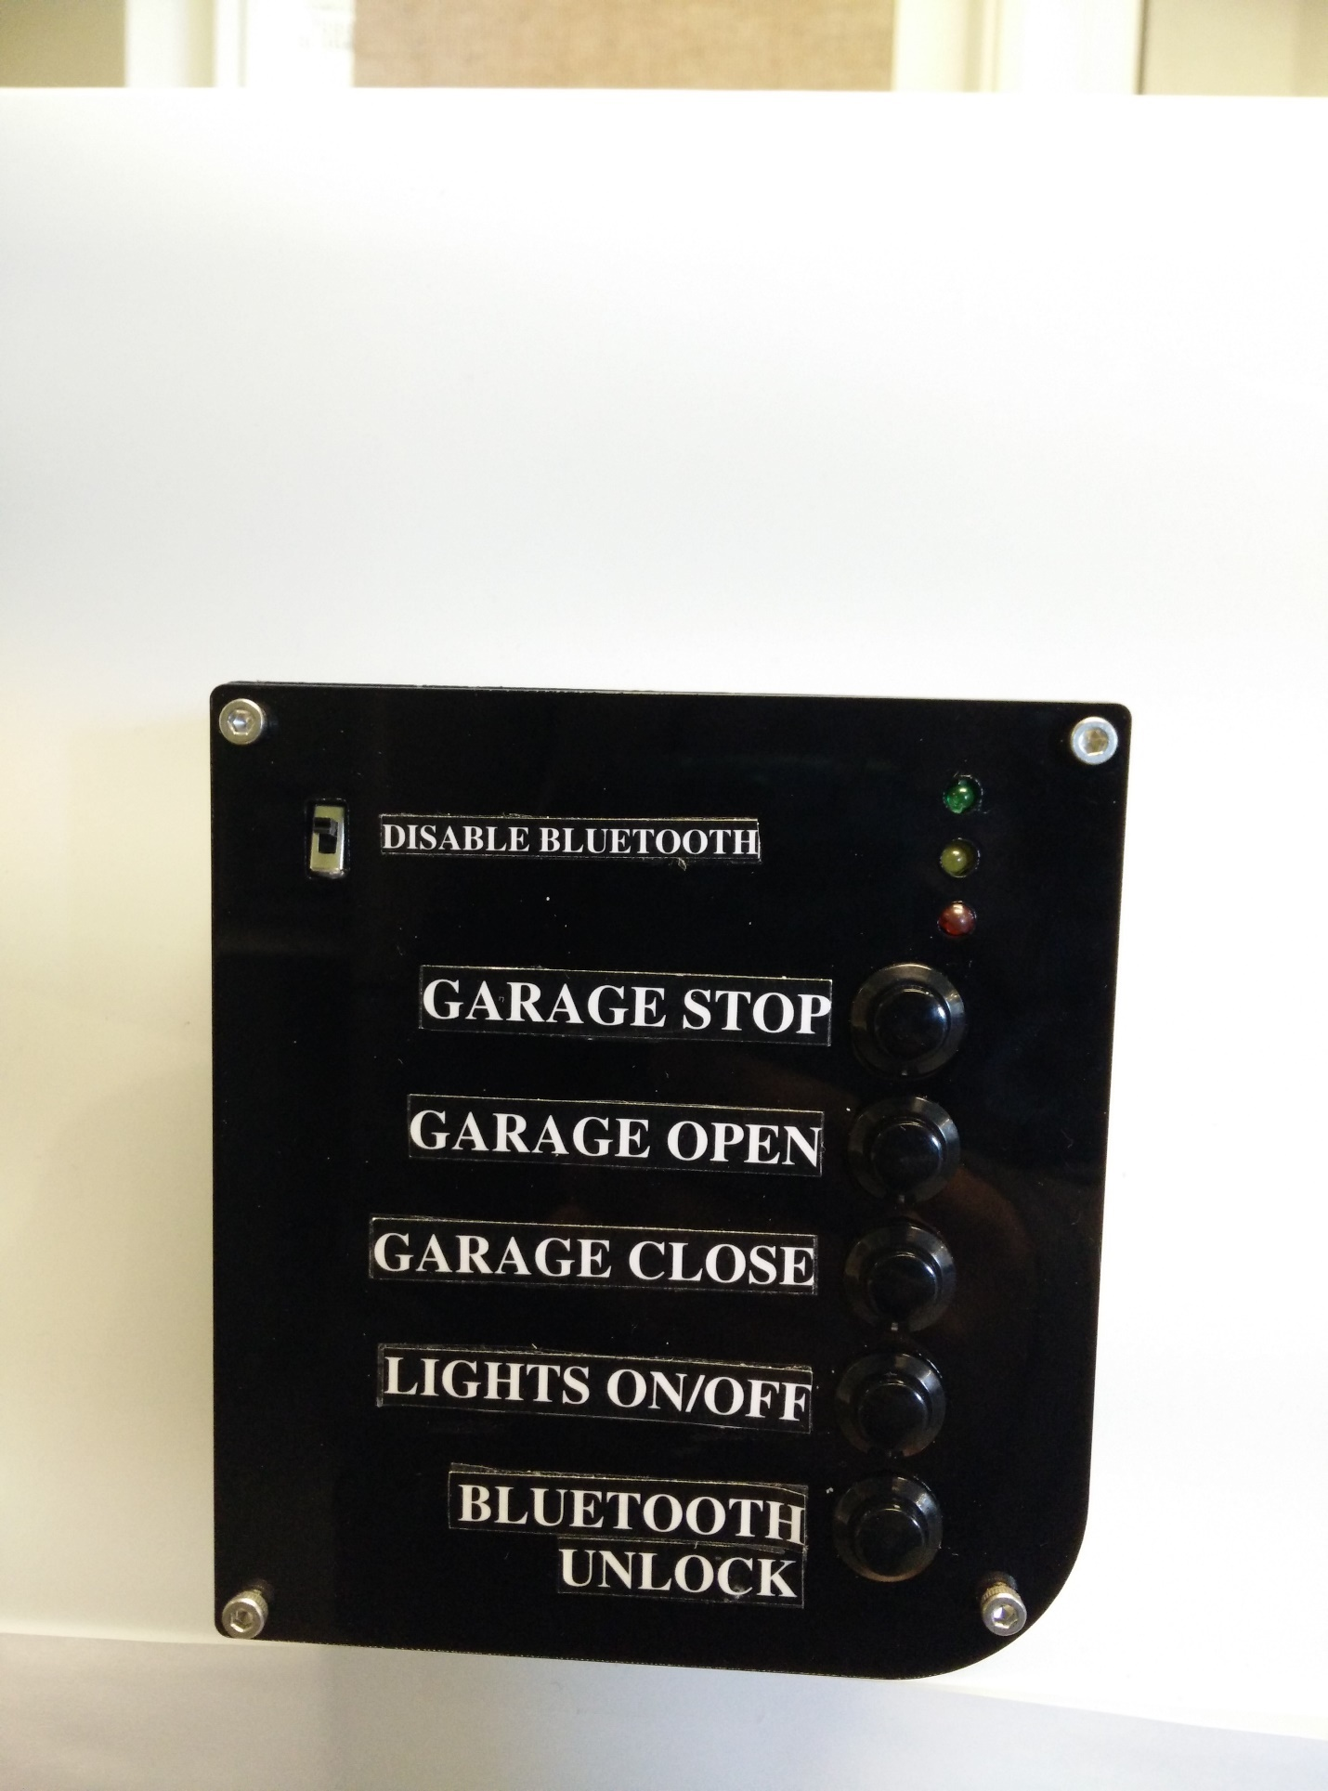

The GateBox panel is used to control the homeowner's garage door. Within the panel there is a custom relay shield that is controlled by a micro controller. On the main panel, there are 5 buttons. The 3 of the 5 buttons are used to stop, open, or close your garage. The fourth button is used to control the lights and the fifth button is used to unlock your Bluetooth panel. The sliding switch located at the top left is placed there for security purposes. If the homeowner decides to go on vacation and wants their panel to stop broadcasting, all they have to do is toggle the switch down. The LEDs are indicators to show an established connection between the panel and the car. The electronics inside the panel are:

1. main board
   1. This board consists of 4 mechanical relays, 5 push buttons, a barrel jack for power, a voltage regulator, resistors, diodes, capacitors, transistors etc. Please see parts list. The main board is powered by a 9V dc barrel jack adapter.
2. LED board which is attached to the main board by jumper cables.
3. Bluetooth low energy chip (nRF 8001 from Nordic) which is connected to the main board through header pins.

The device is meant to be up and running 24/7. Of the four mechanical relays, three are normally open and one is normally closed.

|  |  |  |
| --- | --- | --- |
| **Button** | **State** | **Voltage** |
| Garage Door Stop Button | Normally Closed | 0 - 24 VDC |
| Garage Door Open Button | Normally Open | 0 - 24 VDC |
| Garage Door Close Button | Normally Open | 0 - 24 VDC |
| Lights Button | Normally Open | 120 - 240 VAC |

These relays can be operated by the push buttons or a command from the homeowner’s smartphone which is received by Bluetooth Low Energy chip. In either case, the command is first sent to the ATMega328PU microcontroller first which then sends a signal to the relay.

The enclosure of this device is made of 3mm thick acrylic. The device is meant to be wall mounted at least 5 feet above the ground.

The panel is compatible with most garage openers on the market today such as Liftmaster or Chamberlain. The contacts of the garage door and lights can be directly wired into the terminal blocks of the relay shield, and then the homeowner can begin accessing their garage door and lights via their car. We see a brilliant future where the world around us is further connected with smart sensors and devices which allow for a smoother and more effective interaction with the world around us.

**Custom Board Bill of Materials**

|  |  |  |  |  |  |
| --- | --- | --- | --- | --- | --- |
|  |  |  |  | Total Costs | **$28.7778** |
| Part | Digikey/ Element14 Part No. | Manufacturer Part No. | Quantity | Picture | Cost |
| Atmega 328p Microcontroller | 68T2944 | ATMEGA328P-PU | 1 |  | $3.24 |
| 16 MHz Crystal Oscillator | 18C1481 | XT9S20ANA16M | 1 |  | $0.338 |
| 28 pin DIP IC Socket | 34P8056 | 4828-3004-CP | 1 |  | $0.503 |
| Rectifier Diode 1A, 50V | 10M8464 | 1N4001 | 1 |  | $0.113 |
| LM-7805-CT Voltage Reg. | MC7805CTG | MC7805CT-BPMS-ND | 1 |  | $0.487 |
| Switch Tactile SPST-NO | MJTP1230 | 679-2428-ND | 2 |  | $0.1124 |
| Terminal blocks | ED1623-ND | ED500/2DS | 4 |  | $0.85 |
| 2.1mm DC Barrel Jack | CP-037A-ND | PJ-037A | 1 |  | $1.23 |
| 100uF, 25V Electrolytic Cap. | 39T8695 | 25YXH100MEFC6.3X11 | 2 |  | $0.075 |
| 22 pF, 50 V Ceramic Cap. | BC1034TR-ND | K220J15C0GF5TH5 | 2 |  | $0.34 |
| 3mm LED, FWD V= 2.1V/I= 20 mA | 94T8843 | 703-0087 | 3 |  | $0.184 |
| 10K Ω Resistor, 1W, 5% | 95W5667 | CFR100J10K | 8 |  | $0.18 |
| 1K Ω Resistor, 1/4W, 5% | 25M8365 | CBT25J1K0 | 7 |  | $0.32 |
| 6 Pin Male Header | 609-3263-ND | 68000-406HLF | 4 |  | $0.24 |
| G5V-1-DC Low Signal Relay | Z773-ND | G5V-1-DC5 | 4 |  | $2.77 |
| SPDT Sliding Switch | CKN9565-ND | OS102011MS2QN1 | 1 |  | $0.54 |
| DIODE GEN PURP | 1N4148TACT-ND | 1N4148TA | 4 |  | $0.14 |
| Transistor NPN | 2N3904FS-ND | 2N3904BU | 4 |  | $0.26 |

**NRF8001 BLE Board Bill of Materials**

|  |  |  |  |  |  |
| --- | --- | --- | --- | --- | --- |
|  |  |  |  | Total Costs | $23.7681 |
| Part | Digikey/ Element 14/ Mouser Part No. | Manufacturer Part No. | Quantity | Picture | Cost |
| BLUETOOTH LW ENERGY nRF 8001 | 1490-1026-ND | nRF8001-R2Q32-T | 1 |  | $5.72 |
| HIGH-LOW LEVEL SHIFTER | 568-8150-1-ND | 74HC4050D,653 | 1 |  | $0.606 |
| Capacitors Solid SMD 10uF | 718-1126-2-ND | 293D106X96R3A2TE3 | 2 |  | $0.229 |
| LDO Voltage Regulators High | 576-2980-2-ND | MIC5225-3.3YM5 TR | 1 |  | $1.28 |
| CAPACITOR 15PF 50V, C0G, 5%, 0402 | 38K1652 | GRM1555C1H150JZ01D | 4 |  | $0.106 |
| CRYSTAL 32.7KHZ 12.5PF SMD | SE2415CT-ND | FC-255 32.7680K-A3 | 1 |  | $1.69 |
| Capacitor SMD 33 nF 25 VDC 0402 | 65-754-51 | GRM155R71E333KA88D | 1 |  | $ 0.683 |
| CAPACITOR, 0402 0.1NF 50V | 578095 | CM05CG101J50AH | 2 |  | $1.00 |
| Capacitor SMD 0.1uF 25volts | 478-7868-1-ND | 04023C104KAT2A | 1 |  | $0.471 |
| CAP, MLCC, X7R, 1NF, 50V, 0402 | 490-1303-1-ND | GRM155R71H102KA01D | 1 |  | $0.368 |
| CAP SMD 10UF 6.3V 20% 0402 | 81-GRM155R60J106ME4D | GRM155R60J106ME44D | 1 |  | $0.444 |
| CAP, 1.5pF 50V C0G ±0.1pF SMD | 490-8087-1-ND | GJM1555C1H1R5BB01D | 1 |  | $0.10 |
| CAP SMD 0402 22pF 50V C0G 5% | 581-04025A220J | 04025A220JAT2A | 1 |  | $0.135 |
| CAP SMD 0402 1.8pF 50V C0G | 81-GJM1555C1H1R8BB01 | GJM1555C1H1R8BB01D | 1 |  | $0.283 |
| CAP, MLCC, 2.2NF, 50V, X7R, 0402 | 2310511 | MC0402B222J500CT | 1 |  | $0.11 |
| RESISTOR, 10K, 0.06W, 0402, SMD | 541-10.0KLCT-ND | CRCW040210K0FKED | 1 |  | $0.59 |
| RES SMD 22K OHM 0.1% 1/10W 0603 | P22KDBCT-ND | ERA-3AEB223V | 1 |  | $0.91 |
| EMI Filter Beads, Chips & Arrays | 810-MMZ1608B121C | MMZ1608B121C | 1 |  | $0.135 |
| 8.2nH SMD Inductor, 4.9GHz | 810-MHQ1005P8N2JT | MHQ1005P8N2JT | 1 |  | $0.34 |
| INDUCTOR, 10NH, 2%, 3.9GHZ, SMD | 994-0402CS-10NXGLU | 0402CS-10NXGLU | 1 |  | $1.69 |
| INDUCTOR, 15NH, 5%, 3.28GHZ, SMD | 994-0402CS-15NXJLU | 0402CS-15NXJLU | 1 |  | $1.40 |
| INDUCTOR,3.9NH, 5%, 9.5GHZ, SMD | 994-0402HP-3N9XJLU | 0402HP-3N9XJLU | 1 |  | $1.54 |
| INDUCTOR, 5.6NH, 2%, 6.5GHZ, SMD | 994-0402HP-5N6XGLU | 0402HP-5N6XGLU | 1 |  | $1.34 |
| CRYSTAL 16MHZ 9PF SMD | SER3636CT-ND | TSX-3225 16.0000MF18X-AC | 1 |  | $0.91 |
| U.FL SMD Antenna Connector | 798-U.FL-R-SMT10 | U.FL-R-SMT(10) | 1 |  | $1.59 |

**Schematic of Custom Board (*created using Eagle CAD)***

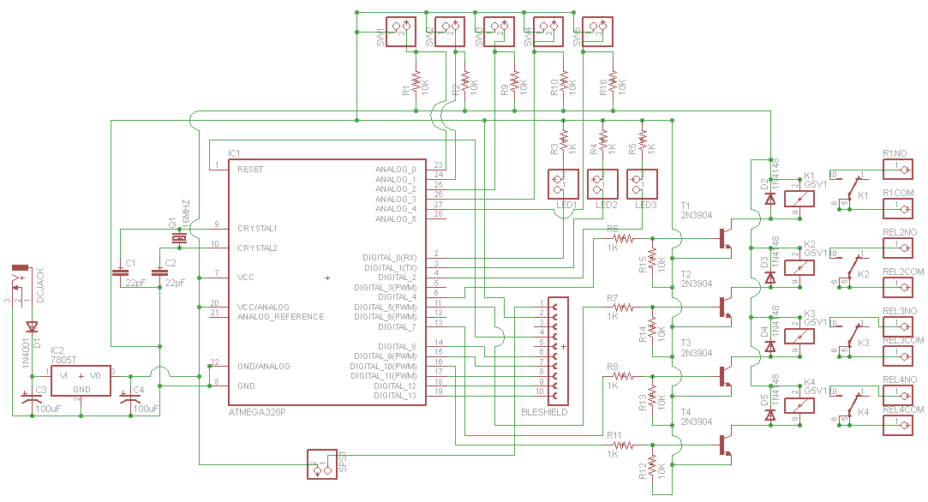

**Layout of PCB (*created using Eagle CAD)***

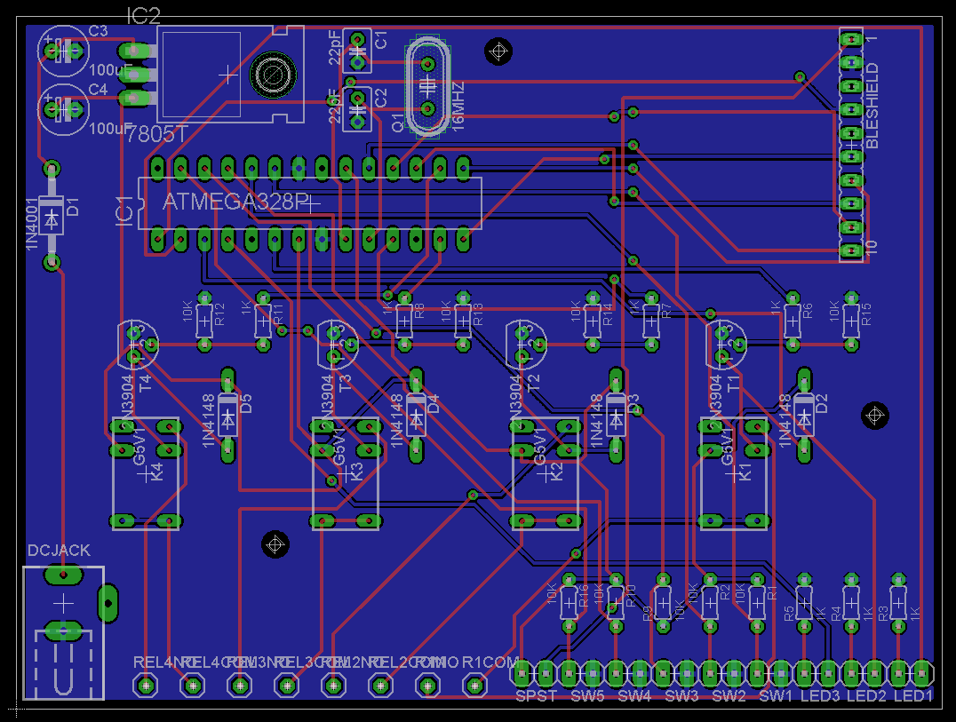

**The GateBox panel was designed in Solidworks**

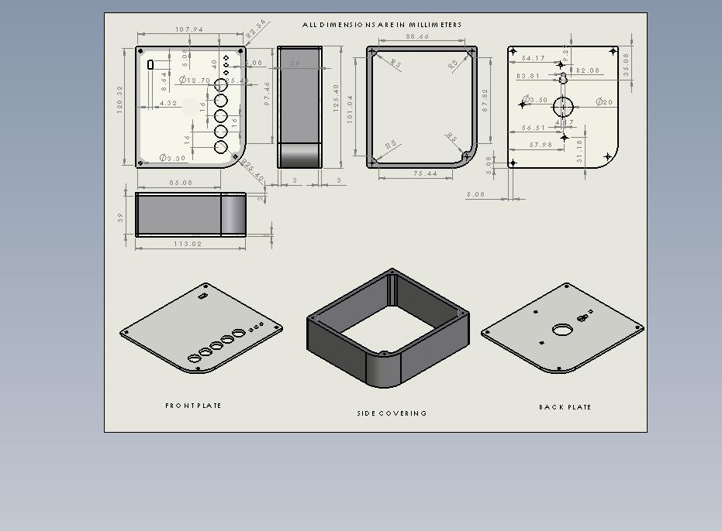

**Safety Concerns**

* The wall console/push button should be mounted at least five feet from the floor and the remote controls should be kept out of the hands of children. Children should never be allowed to play with or use the garage door opener remotes or wall pushbuttons. Homeowners should also keep a moving door in sight until it fully opens or closes.

Source: <http://www.dasma.com/safetygdguide.asp>

* Must be installed by a licensed electrician.
* Do not run any low voltage control wires close to the 120-volt power line. Do not run any wires through the same holes as the 120-volt power line in studs or cross ties. Either of these conditions will not comply with the NEC and may interfere with safe operation of the garage door operator.
* You will need 3 lengths of 2 conductor color coded minimum 22-gauge bell wire (phone wire) suitable for Class 2 installation. In Canada, this wire must be CSA certified.
* Emergency Stop button allows for the door to stop immediately whether it is going up or down.



**Emergency Stop Button**

**Other Similar Projects/Products**

|  |  |
| --- | --- |
| HomeLink | <http://homelink.com/home/welcome> |
| Bosch Hackathon 2nd Place Winner (Not a competitor, has not produced a product out of this demo). | <http://blog.bosch-si.com/categories/mobility/2014/10/how-can-we-bring-the-garage-into-the-car/> |
| Other systems allow door activation over the Internet to allow home owners to open their garage door from their office for deliveries. | <https://www.liftmaster.com/For-Homes/Garage-Door-Openers/Elite-Series/model-8550> |
| The Overhead Door® Advanced Wall Console has been designed to not only provide homeowners with advanced security, but to deliver more control over their garage door opener, its lighting and opener performance status. The console is programmable to provide service reminders and contact information for the local Overhead Door Red Ribbon Distributor, making annual maintenance easy and convenient. | <http://www.overheaddoor.com/garage-door-openers/Pages/advanced-wall-console.aspx>  <http://www.overheaddoor.com/garage-door-openers/Pages/garage-door-opener-accessories.aspx> |
| Bluetooth switch | <http://www.ablenetinc.com/Assistive-Technology/Computer-Access/Blue2-Bluetooth-Switch> |
| My door open iPhone app | <https://itunes.apple.com/en/app/mydooropener-elite/id359774310?mt=8> |
| iWUP | <http://www.instructables.com/id/Garage-Door-Opener-with-iphone-Arduino-project/?ALLSTEPS> |